1. A F&B manager wants to determine whether there is any significant difference in the diameter of the cutlet between two units. A randomly selected sample of cutlets was collected from both units and measured? Analyze the data and draw inferences at 5% significance level. Please state the assumptions and tests that you carried out to check validity of the assumptions.

ANS=

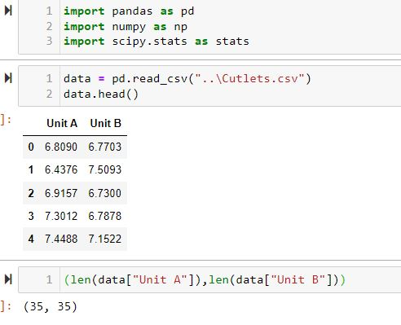

**Population:** Company

**Parameter of Interest:** 𝜇1−𝜇2μ1−μ2, Diameter of Cutlet

**Null Hypothesis(H0):** 𝜇1=𝜇2μ1=μ2 (There is no significant difference in the diameter of the cutlet between two units)

**Alternative Hypthosis(Ha or H1):** 𝜇1≠𝜇2μ1≠μ2 (significant difference in the diameter of the cutlet between two units)

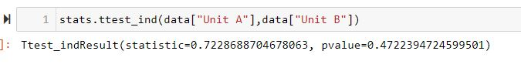

Since, the pvalue is < 0.05 , will reject the null hypotesis,

Ans : significant difference in the diameter of the cutlet between two units

2.A hospital wants to determine whether there is any difference in the average Turn Around Time (TAT) of reports of the laboratories on their preferred list. They collected a random sample and recorded TAT for reports of 4 laboratories. TAT is defined as sample collected to report dispatch.

Analyze the data and determine whether there is any difference in average TAT among the different laboratories at 5% significance level.

ANS=

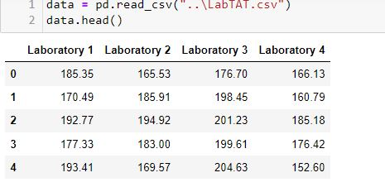

Population: 4 Laboratory of hospital

Parameter of Interest: 𝜇1−𝜇2 ,Turn Around Time (TAT) of reports of the laboratories

Null Hypothesis(H0): 𝜇1=𝜇2=𝜇3=𝜇4 (there is no difference in the average Turn Around Time (TAT) of reports of the laboratories)

Alternative Hypthosis(Ha or H1): At least one of the 𝜇 is different from others

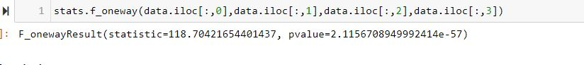

Since the pvalue is samlle than alpha(0.05) ,we can reject the null hypotesis & we can conclud that there is difference between at least one the liboratory ,Turn Around Time (TAT) of reports.

data = Buyer Ratio.mtw

4. Sales of products in four different regions is tabulated for males and females. Find if male-female buyer rations are similar across regions.

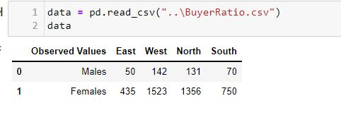

Null Hypothesis(H0): All proportions are equal (male-female buyer rations similar across regions)

Alternative Hypthosis(Ha or H1): Not all Proportions are equal (male-female buyer rations are not similar across regions)

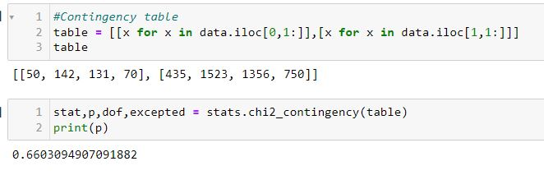

Since the pvalue is less than alpha , we are fail to reject null, we can conclud that Not all Proportions are equal

4. TeleCall uses 4 centers around the globe to process customer order forms. They audit a certain % of the customer order forms. Any error in order form renders it defective and has to be reworked before processing. The manager wants to check whether the defective % varies by centre. Please analyze the data at 5% significance level and help the manager draw appropriate inferences

ANS=

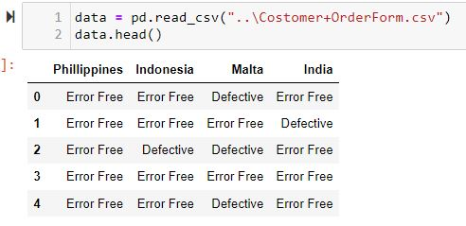

Null Hypothesis(H0): All Centers has equal Defective %

Alternative Hypthosis(Ha or H1): Defective % varies by centre

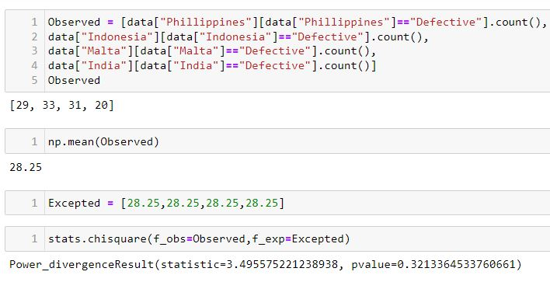

Since the pvalue is more the Alpha , Fail to reject the null, we can conclud that All centers are Equal Defective porpostion.

1

​